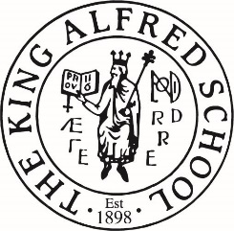

Dear Parents

**King Alfred School Reception Year – Entry for September 2024**

We will have 40 places available in our two Reception classes in September 2024. We invite the children in for visits in registration order. Prior to the visit we will ask for a report from your child’s nursery, and to complete an additional information form. If the visit goes well, and we feel that your child will thrive at King Alfred School, a place will be offered. We will contact you a few weeks beforehand if your child is to be invited for a visit to the school. We will only invite a child to visit if there is a possible place available for them.

However, we usually arrange reserve groups at the end of the process from which we fill later vacancies, should they arise.

***If you do not hear from us, it means we have not reached your child on the waiting list.***

There is always a chance we may contact you after the main entry process if places become available subsequently.

**The Reception visits**

The visits will take place during November 2023 (dates to be confirmed). Children are invited in small groups, and the visit sessions will last for approximately one hour. The children will spend this time with the reception teachers doing a variety of age-appropriate activities.

At the same time, parents are invited to meet Karen Thomas, Head of the Lower School, to discuss your child, as well as giving you opportunities to ask questions. Our Admissions Policy on the school website: <https://www.kingalfred.org.uk/about-us/policies/> explains this process fully.

We look forward to hearing from you,

Gill Newsam Caren Barnett

**Admissions**

[admissions@kingalfred.org.uk](mailto:admissions@kingalfred.org.uk) Tel: 020 8457 5285/5170